**CHAPTER 1**

**INTRODUCTION**

**1.0 Executive Summary**

Efficiency and productivity are two qualities that are increasingly establishing their dominance as keywords companies are using to market their products. The fact that their product can multitask or increase productivity better than the competition has become a real selling point. This is due to the fact that effective time management is an essential factor in increasing production of day-to-day life. The best time management strategies involve being able to find time where there was no time before. Integration of technology into people’s daily lives has made that time management possible. The use of products such as tablets, PCs, and smartphones have given people access to the tools needed to be productive.

However, though successful technological products have been used to increase productivity, it has done its fair share to stifle it as well. The use of technology has become another task on everyone’s daily to-do list. Technology should mold to our schedule, not the other way around. That is where the smart mirror idea originated. The smart mirror idea aimed to integrate technology seamlessly into people’s lives by putting it where everyone’s routine eventually collides, the bathroom. The goal of the smart mirror is to increase a user’s productivity by saving them time. The smart mirror provides a near effortless experience that allows the user to just walk up and be greeted with information they would typically need another device for. Despite the fact this information can be found on the user’s other devices, it’s the time-saving convenience of having this information available during the typical bathroom routines.

The smart mirror has the necessary applications and features needed for time efficiency focused device. First, there is the easy on and off. The mirror automatically recognizes that there is a user present and turns on the screen hidden behind the two-way mirror. A suit of six applications are presented on the 32” high-definition screen surrounded by a framed encasing that contains speakers and a webcam. These apps include weather, Twitter, news, to-do list, calendar, and music. The smart mirror application is run from a central computer

To develop a design of this size, significant research had to be done. First, similar projects and products had to be investigated to what has been done and possibly what needs to be done. Next, the individual pieces of the mirror had to research in order to decide on the best product to use in the smart mirror system. Some of these topics included the gesture control, voice recognition system, MCU, and hard drive type. Once the comparisons were made, each component was analyzed on how it will function within the system and what it has to offer.

The design of the smart mirror was broken down into subsystems that represent important components of the project. Since there are hardware and software components to design, a block diagram was needed for both. The technical specifications were written for each subsystem for documentation and reference during the prototyping stage. The design contained charts, state-diagrams, and circuit designs regarding the details relating to what was prototyped. Once completed, the smart mirror delivered the experience of technology becoming part of a user’s routine and not an extra task.

**CHAPTER 2**

**PROJECT DESCRIPTION**

**2.0 Literature survey**

**2.1 Motivation**

Effective time management is one of the most important factors for success and productivity in a person’s day-to-day life. With the increasing integration of technology in our lives, maintaining an efficient schedule has become both easier and more difficult. Keeping up to date with appointments, Twitter, news, social media, and other things is made easier through technology such as tablets, PCs, and smartphones yet also provide distractions that can interrupt anyone’s routine. Technology has become another task in the day that time must be allotted for. In the finite time of the day, technology needs to be designed to work within our schedule and not be an extra piece to it.

The key to effective time management involving technology is multitasking. Anyone in the business or academic world would agree that every second counts in the day. This project was formulated through inspiration seen through movies such as Iron Man and tech demos, such as Samsung’s transparent LCD Smart Window, seen at the International Consumer Electronics Show in 2012. This extends as well to the continuing trend of integrating touchscreens and internet-connectivity into everyday appliances such as ovens and refrigerators. The idea of a smart home is the direction lots of companies are heading and while the kitchen has been getting lots of attention, the bathroom has not. Besides the kitchen, the bathroom is one of the busiest rooms in the home, so it is an excellent place to expand the smart home next.

Constant information and instant access to it drive the current generation. Forget bringing smartphones and tablets into the bathroom and risking damage. The smart mirror will show you that information with the swipe of a hand. The smart mirror is the result of our team brainstorming on how to solve all these issues and develop something that is functional as well as a showpiece.

**2.2 Goals and Objectives**

The smart mirror must offer benefits of using modern technology while integrating seamlessly into the standard bathroom routines of most people. The smart mirror must be simple and as intuitive as possible. The smart mirror would be used to merge technology and the need for information into anyone’s daily schedule. With the mirror in place, the 3 user could interact and obtain the information they want during their normal morning and night bathroom routines.

This smart mirror aims to reduce and possibly eliminate the need for the user to make time in their daily morning or nightly routine to check their PC, tablet, or smartphone for the information they need. The mirror will provide the information with little to no effort from the user with the goal of not being a burden that he or she must maintain. The mirror wouldn’t be another activity, rather an enhancement to the already common use of mirrors in most modern bathrooms.

The mirror will do the thinking for the user. First, it will turn on and off by itself. Then, it will update with the user’s calendar schedule, to-do lists, Twitter, news, and weather. The information wouldn’t be thrown in the user’s face, but unobtrusively displayed on the edges of the mirror to still allow use of the actual mirror. The use of touch-less gestures will keep things simple and easy to use. No keyboards to try to keep dry and clean. The gestures will also allow the user to still use the mirror despite whether their hands are wet or dirty. The mirror provides common information most people check their smartphones or tablets for, such as weather, news, Twitter and schedules. This allows the users to read, think, and plan their day while getting ready in the morning or night. The mirror has to be fun as well. It will provide music playback that can be controlled by their voice so there is no need for a mouse or keyboard.

Finally, the mirror must be smart enough to protect itself from the wet and humid conditions that occur in every bathroom. It will feature a humidity protection system where it will monitor the temperature and humidity levels near the hardware. If the temperature or humidity levels are out of the safe operating range, then a failsafe system will notify the PC system so it can shut off to prevent damage.

**2.3 Research related to Project Definition**

**2.3.1 Existing Similar Products and Projects**

The projects and products similar to our smart mirror project cover a large spectrum of functionality and purposes. There were significantly more projects than actual products. Some blame can be put on the fact that the smart home is still an emerging market and is limited by the cost of manufacturing keeping the products out of reach from the everyday consumer. The fact that there were more projects shows the interest in developing a more affordable and functional smart mirror. Although, the actual products developed by a company delivered on features, they were either still in a development phase or already priced too high to be considered a viable competitor.

**2.3.2 Projects**

The following projects showed how the smart mirror can be designed in so many various ways. Each brought unique ideas and features to the term “smart”. Not all of these projects were designed and built in the same year, so there is a noticeable difference in terms of use of available technology. Our smart mirror project has overlapping ideas with each of these projects but none of them are exactly the same. The projects researched are found below.

Interactive mirror is a touch and gesture functional mirror created by Alpay Kasal and Sam Ewen of Lit Studios. The user touches the mirror, which has a built in touchscreen, to interactive with it. Unlike our smart mirror project, only one point of touch is recognized because it is emulating a mouse. Also, this mirror is less about data and more about artsy visuals. Users in the demo video show off different types of drawing and 2D games that are displayed using a projector. The fact that it emulates a mouse is nice because of the expandability and the range of functions capable. Yet, this still differs from our smart mirror since it isn’t made to solve anything, only entertain.

The HUD mirror was designed by five students for a course at the Chalmers University of Technology in Sweden. They used a two-way mirror to allow the LEDs they mounted behind to illuminate information through the mirror similar to how the smart 6 mirror will display information. This mirror was made for the bathroom and displayed time, weather, outside temperature, and a toothbrush timer by use of the LEDs. The toothbrush timer is actually a useful feature that our smart mirror project should consider. Also, instead of using a touchscreen for interaction, they used light dependent resistors (LDRs) as buttons behind the mirror. When “touched”, the light changes and can perform a function specified in the Arduino software. Despite being simpler, the HUD mirror has a lot of the same ideas as the smart mirror.

The smart mirror was developed by the New York Times Research and Development Lab. It uses a TV with a mirror finish and uses a Microsoft Kinect to track movement and take in voice recognition. Also, it integrated a RFID reader to identify certain bathroom products. The whole system is run from a Windows PC just as the smart mirror will. The fact it can keep track of prescriptions and use the Kinect to “virtually” put clothes on the user are very inspiring features that given more time we’d love to integrate into the smart mirror. The smart mirror also allows the ability to check email, calendars, and social media, which confirms that our smart mirror will offer features that users are expecting.

**2.3.3 Products**

The smart mirror is definitely not a true consumer product yet. There are very few truly manufactured and ready for sale smart mirrors in the market. Those that are there are very different in terms of functionality, development, and price. It is certainly going to take a large smart home company to get behind this product and make it main stream to the consumer. Each product did have a common feature, which was health management such as weight. This is something our smart mirror doesn’t have a direct focus on and maybe would be something to change in the design if our project were to go public. The products researched are found below.

The android-powered mirror created by the Japanese company, Seraku uses an android table to power the mirror. An LCD monitor covered with a semitransparent reflective glass is used to make the mirror. The mirror contains apps such as weather, news, weight, temperature, and water flow. Water flow is an interesting addition and could be excellent in helping water conservation. The mirror also uses RF proximity sensors to interact with the mirror with similar hands-free reasoning to why our smart mirror is using the Leap Motion controller. This mirror also comes paired with a scale, for analyzing and keeping track of the user’s weight. The product isn’t commercial ready so there is no estimate of price. A user’s health is definitely the marketing point to actually selling interactive mirrors, despite manufacturing costs probably holding them back.

The Cyber-tecure Mirror is an actual product sold in Hong Kong. It is made with a mirror screen and uses a cable TV similar remote, or smartphone, to navigate its applications. The mirror is equipped with Wi-Fi, two stereo speakers, fog resistant glass, and parts designed to operate even under bathroom humidity. The interface contains simple apps that allow for different user profiles. Apps include weather, social media, TV programs, virtual lighting, and health information. The health information is gathered 7 through a scale that is paired with the mirror. This mirror is truly a design and engineering goal for our smart mirror. It contains almost all the features of the smart mirror plus some extra. Though, the virtual vanity lighting seems to lack the true function of real lighting. Overall, an impressive mirror and shows that this type of mirrors are possible. Our smart mirror project aims to be over 80% cheaper to produce.

**2.4 Open Technology and Standards**

* [**Node.js**](https://nodejs.org/): Node.js is an open-source, cross-platform JavaScript run-time environment for executing JavaScript code server-side. Node.js flexibility with the database made it the best choice for us in the backend.
* [**Electron**](https://electronjs.org/): is a framework for creating native applications with web technologies like JavaScript, HTML, and CSS.

**CHAPTER 3**

**PROPOSED SYSTEM AND COMPONENTS**

**3.0 Introduction**

Interactive computing, with wirelessly connected embedded devices that are being used in various day– to–day activities, are changing and improving the standards of the quality of life. Based on this interactive computing and communication technologies, many devices/products are now emerging and with this multimedia intelligence it is providing comfortable, secure and convenient personal services everywhere whether it is home or various industries and making a lot of users comfortable. We look at the mirror daily and interact with it psychologically to find out how we look and how our attire is. The interactive mirror is a development effort to augment the mirror with proper embedded intelligence for offering enhanced features such as weather of the city, latest updates of news and headlines and local time corresponding to the location. The Smart Mirror would help in developing smart houses with embedded artificial intelligence, as well as finding its applications in industries.

Day after day we are moving towards a more automated and interconnected world because of various wirelessly connected embedded devices. These are responsible for changing and improving the standards and quality of living. Many devices are being developed which use concepts of multimedia communication, artificial intelligence, internet of things (IoT) to revolutionizing the way we perform our various day to day tasks in our home, offices or even industries. Most of us use mirrors every day to look at ourselves; we psychologically interact with the mirror every day to check how we look and how our attire is while getting ready for our work or colleges. So, the idea of having an interactive mirror that can respond to your commands can excite anyone. Smart mirror aims at augmenting the basic reflective mirror with embedded intelligence to combine daily routine tasks like reading newspaper, getting stock updates, weather updates etc. and providing all that data to the user while he/she gets ready. The Smart mirror will help in automating our work and development of smart houses. This paper provides a detailed idea of theory of design and practical implementation of Smart mirror.

**3.1.1 System Overview**

Proposed system and block diagram for smart mirror. The aim of designing this model is to create an interactive interface which can be conveniently used in home environment as well as commercial space. Various services like weather, calendar, traffic, news stock updates etc. can be accessed and controlled using voice commands. The Raspberry Pi 3 is connected to a Monitor via HDMI cable and a webcam is attached using a universal serial bus. Raspberry Pi is powered up using a 5V/2A DC supply.

**3.1.2 Raspberry Pi 4**

Raspberry Pi 4 acts as the main control center for this proposed model. The Raspberry Pi is equipped with a micro SD card which can be loaded with operating systems like Raspbian or Windows 10 IoT core. After the OS is running the Smart mirror code will can be implemented on it to run the application. The Monitor will be getting input from RPi using HDMI cable, web-cam for face-recognition and voice commands can be given to RPi using a microphone.

**3.1.3 Dual Purpose Display**

For the purpose of dual functionality, we are using a two-way mirror for the display. It will be attached on top of the monitor using a wooden frame to hold the whole system together. The two-way mirror can act as normal reflective mirror when the monitor is switched off and the data can be simultaneously displayed while the monitor is switched on.

We plan to deliver a working model of Smart mirror by using raspberry pi 3 for smart homes of future as well as commercial uses. The device will look like a normal reflective mirror but would have a monitor attached on one side. A special two-way mirror is used for this purpose as it can act as normal reflective mirror when the monitor is off and can also display various data as soon as the monitor is turned on. This will thus serve both the purposes.

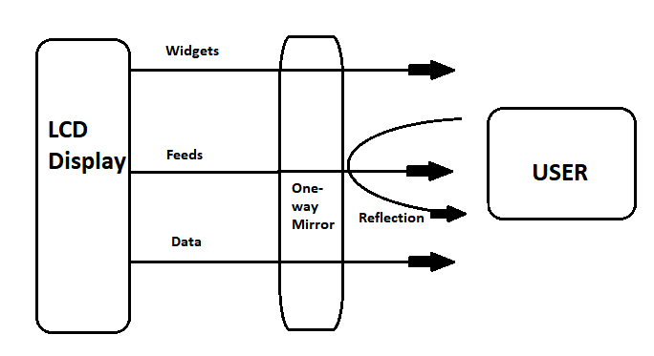

Fig. 1 One-way mirror and LCD display

**3.2 Software Requirements:**

All the software runs on the Raspberry Pi 3 and there are many operating systems to choose from. We chose to use Raspbian which is the official Linux distribution from the Raspberry Pi Foundation because it has a lot of support and documentation.

To install it, we downloaded Raspbian from the official Raspberry Pi website and I copied it on a microSD card. Then inserted the card on the Raspberry Pi, started it and followed the setup instructions which are quite simple. Once Raspbian was installed, the first thing we did was to update the distribution with the latest packages, we configured the basics of the OS as for instance the keyboard layout to match my keyboard and everything was ready to go.

**3.2.1 Development Tools**

Taking advantage of the fact that we already had an operating system running on the Pi, we gave myself the challenge of writing all the code for the Smart Mirror on the same device. We installed Geaney, which is a very lightweight IDE, and I used it to write all the HTML, JavaScript, CSS and Python code.

In the end, the entire coding for the software was done on the Raspberry Pi and we only used my Windows laptop to create icons and designs with Illustrator and Photoshop. It turned out to be very convenient to be able to easily test the software directly on the Smart Mirror.

* **Electron**

Electron is software based on Chromium, the open source version of Google’s Chrome that includes NodeJS and several improvements to make it easy to develop web-based software for desktop computers. The OS was built on top of Electron using web technologies.

* **NodeJS**

NodeJS is a JavaScript engine for server-side applications. It comes included with Electron and we used it to launch processes to control things that are not available in web APIs such as the ultrasonic sensors for gesture input and microphones for voice recognition. We also used it to access the filesystem and read the app files.

* **Python**

Python is a high-level, general purpose, interpreted programming language. It’s very popular in the Raspberry Pi community and it has lots of support and libraries. In our case we used it with the microphone to detect claps and we also used it to control the ultrasonic sensors and detect gestures.

* **User Interface**

The user interface for the OS is clean and simple. It has an overlaid status bar on the top with the time on the right corner, the IP address of the socket server on the left corner and a status message in the center. The status bar is dynamic and changes depending in the context: it can be hidden in case we want watch something in full screen or expanded to show important information.

This user interface is completely responsive so it’s possible to have different sized mirrors and the OS will adapt to it automatically.

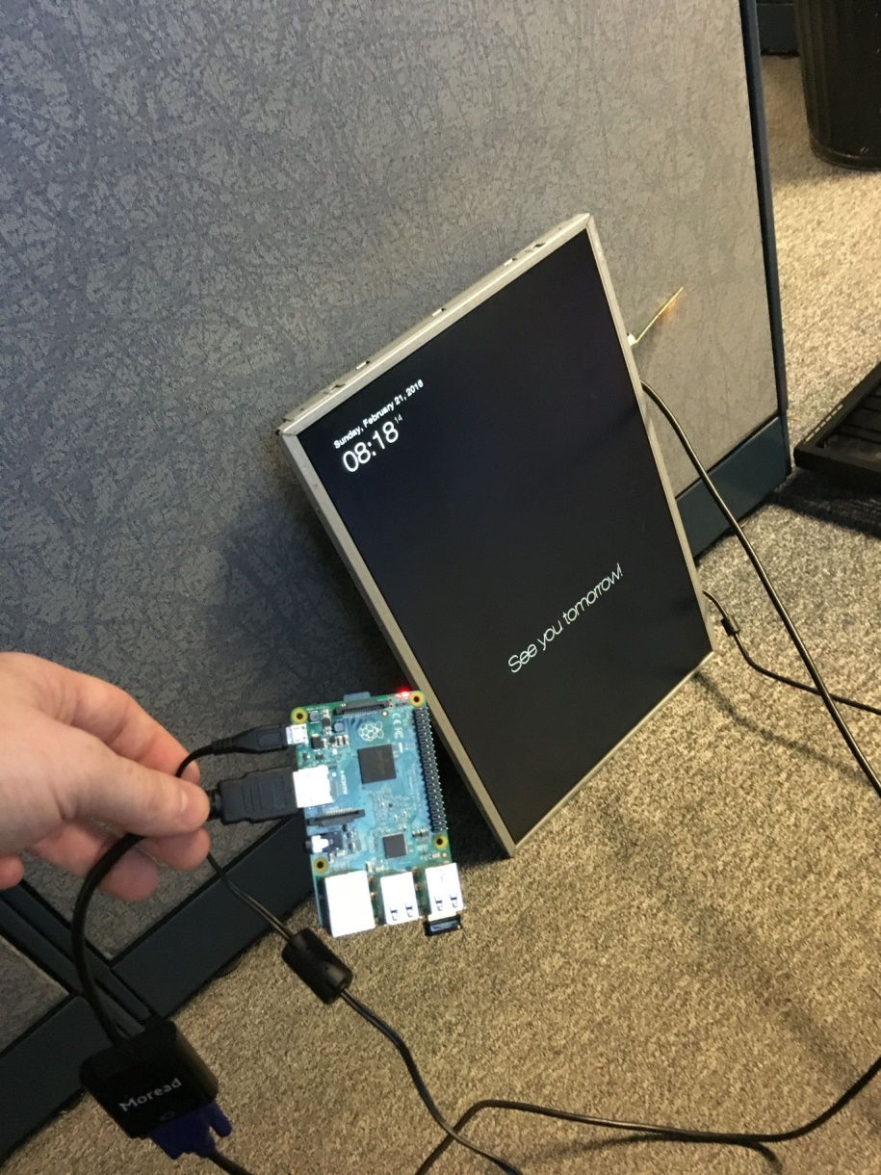

Fig.2 User Interface for Mirror OS

**3.3 Hardware Requirements:**

For the hardware we used a 19” View sonic computer monitor, a 50x90x0.5cm one-way mirror a Raspberry Pi 4, everything was put together in a wooden frame. These are the final sketches for the hardware design:

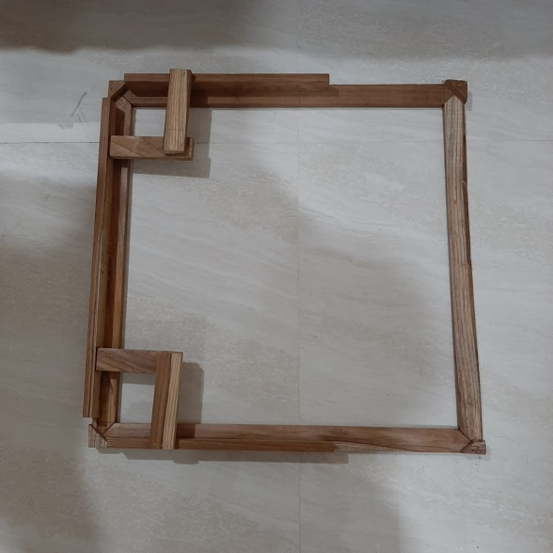

Fig.3Framework

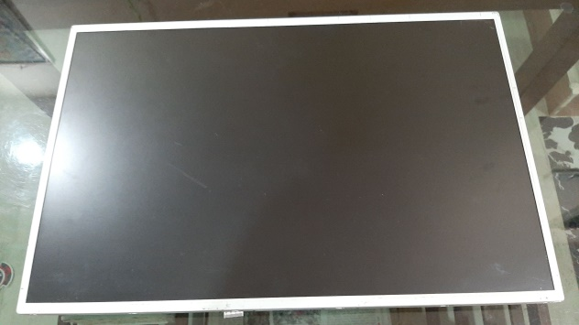

Fig. 4 LCD Screen

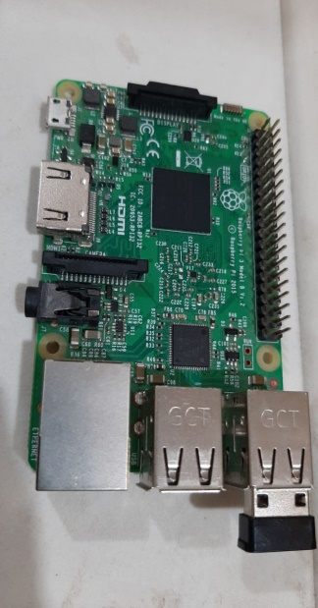

Fig. 5 Raspberry pi 4B

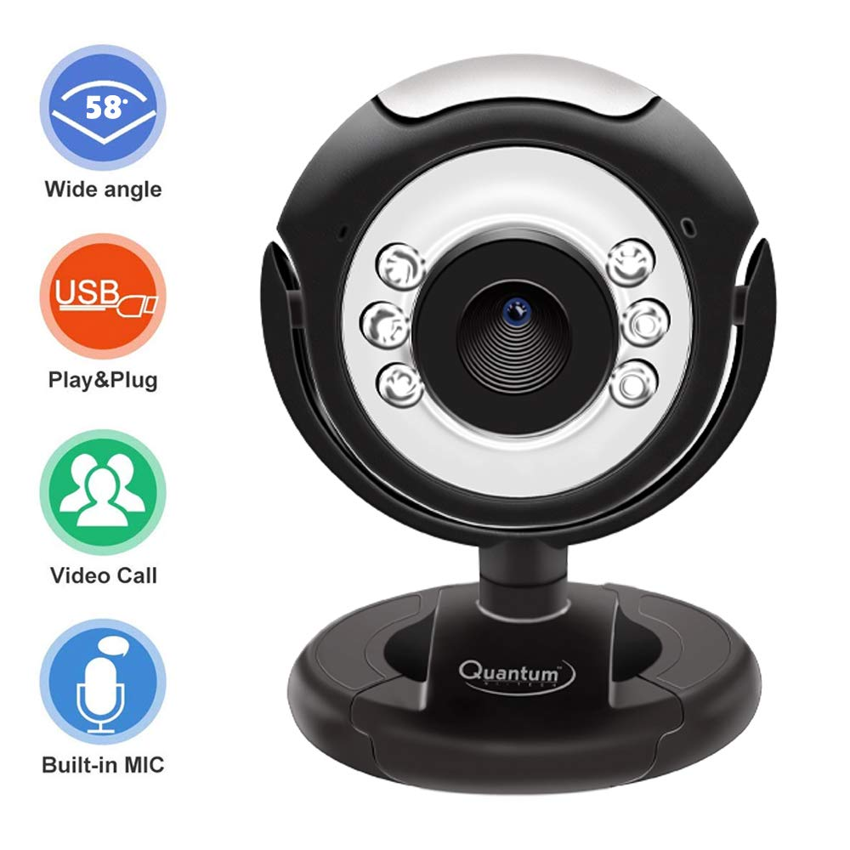

Fig. 6 Webcam

**CHAPTER 4**

**METHODOLOGY**

**4.1 Smart Mirror as a Mirror**

We can see our view as we can see it in a natural mirror while looking and grooming with the help of one-way mirror with high concentration of aluminum content.

**4.2 Smart Mirror as an Information**

System Time, Date, weather details and news are fetched from online using predefined URL. News is fetched from websites like CCN, BBC etc.

**4.3 Algorithm for Information System**

• Step 1: Switch on the power supply.

• Step 2: Get the date, time, and weather details from predefined from URL.

• Step3: Get the news from [www.thehindu.com](http://www.thehindu.com)

• Step 4: In code section write down all the compliments to be displayed on mirror.

• Step 5: Display it on mirror via LCD monitor

• Step 6: Switch off the power supply when it is of no use.

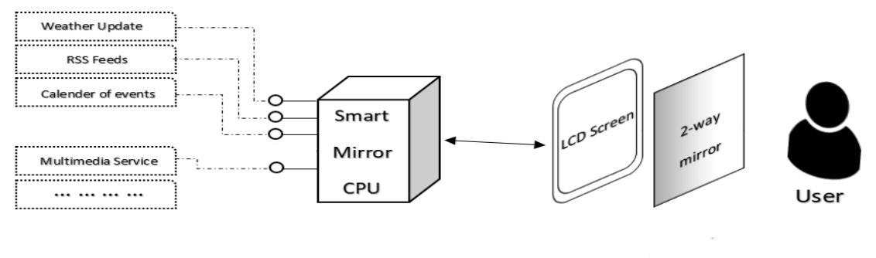

Fig. 7 System Architecture of Smart Mirror

* 1. **Smart Mirror as a Personal Assistant**
* Setup a web camera in front of a mirror and connect it to the raspberry pi board.
* Write down the code for face detection in the raspbian software.
* Check if the face detection is taking place and with it the probability of the face detection.
* Provide the personal information such as messages, emails etc. by linking it with the social media API’s.
  1. **Smart Mirror as an AI Voice Controlled Interaction:**
* Make Smart Mirror work as voice controlled AI device by ALEXA (artificial intelligence).

**CHAPTER 5**

**DESIGN**

**5.1Building a smart mirror**

### 5.1.1 One-way mirror

This is probably the most important part of the hardware because it’s responsible for creating the futuristic effect and is the biggest part of the smart mirror. Wikipedia provides the following definition:

A one­way mirror, sometimes called two­way mirror, is a mirror ​that is partially reflective and partially transparent. When one side of the mirror is brightly lit and the other is dark, it allows viewing from the darkened side but not vice versa (Loy, 1999).

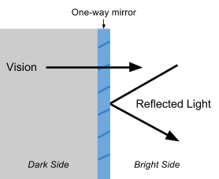

Fig. 8 Schematic diagram of light reflection on one-way mirror

**HTML**

* + - HTML events are the events that happen to HTML events.
    - When Java script is used in HTML pages, Java script can “react” on these events often when events happen, you may want to do something.
    - Java script lets you execute code when events are detected.
    - HTML allows events handler attributes with Java script code, to be added to HTML elements.

**WEB SOCKET**

* Web socket handler provides an interface for upgrading HTTP connection to web sockets and sending or receiving frames on the web socket connection.
* Web socket connections are established through the HTTP upgrade mechanism web socket handler need to be able to first receive the HTTP request for the upgrade, before switching to web sockets and taking over the connection.

**RESTFUL API**

* A RESTFUL API is an application program interface (API) that uses HTTP request to GET, PUT, POST and DELETE data.
* REST technology is generally preferred to be more robust simple object access protocol (SOAP) because REST leverage less bandwidth, making it more suitable for internet usage.

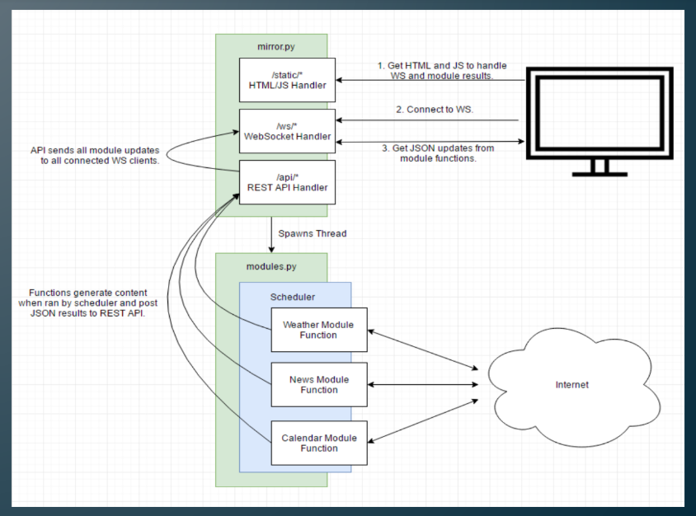

Fig. 9 Workflow of smart mirror

**5.1.2 SECURITY MODULE**

* This is the main theme of the proposed module. This module shows the actual interactive behavior of the proposed system. The Fig. 10 shows the Security module.

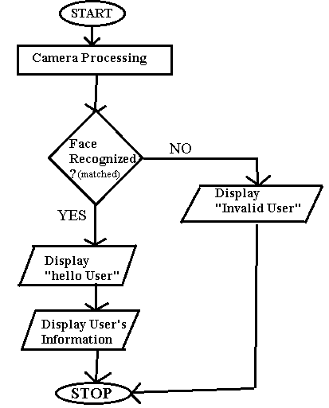

Fig. 10 Workflow of smart mirror

**CHAPTER 6**

**CONCLUSION and FUTURE SCOPE**

**6.0 Conclusion**

The main theme of the proposed work is to design a product bundled with maximum possible features. The system is not just devised as a means of information provider but also an interactive system which can actively be used for Intrusion Detection. The system can be used as security and vigilance system. There is no absolute need of personal monitoring. Smart mirror can be used for the same. The system can be extended as a commercial product. There is a scope for future work in this proposed system by adding Artificial Intelligence. The same mirror can be extended to control the Home Appliances and lighting. Hence, to increase the level of security, face detection can be used for authentication.

**6.1 Future scope**

* In Future, we will investigate how the surrounding context of the user and the environment can be utilized in order to provide optimal experiences.
* We can be able to control Home appliances and lighting, even when we are getting ready for the day.

**REFERENCES**

1. ERCIM Working Group SESAMI, Smart Environments and Systems for Ambient Intelligence. http://www.ics.forth.gr/sesami/
2. PhilipsHomelab.http://www.research.philips.com/technologies/misc/homelab/index.html
3. Tatiana Lashina. Intelligent bathroom, 2004.
4. Chalmers University of Technology in Sweden. 2009 Two-way mirror to allow the LEDs and to display information on screen
5. New York Times Research and Development Lab. 2011 A Magic mirror using Microsoft Kinect to track movements